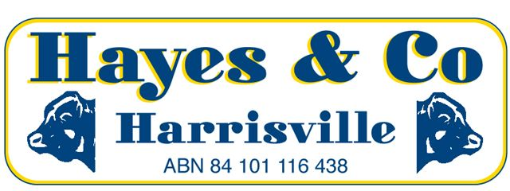
SILVERDALE CATTLE SALE MARKET REPORT

Wednesday 7th September 2016 577 Head

A mixed yarding came to hand this week with cows fully firm. No pasture ox or grain assisted cattle to quote; while all vealers and restocker cattle were again strongly sought after.
Description | C/kg | Vendor | kg | $
COWS | 272.2 | DN & LM JOHNSON | 646 | 1758.00
MEDIUM COWS | 265.2 | G & R WEBSTER | 565 | 1498.00
MEATWORKS BULLS | 274.2 | D GREGOR | 685 | 1878.00
GRAIN ASSIST OX | 327.2 | KINGSTON FAMILY TRUST | 533 | 1742.00
FEEDER STEERS [Heavy] | 351.2 | DW & EM PRATTEN | 439 | 1540.00
RESTOCKER STEERS | 367.2 | B & M HUNT | 311 | 1141.00
PASTURE STEERS | 349.2 | GH HALLAS | 430 | 1502.00
YEARLING STEERS | 369.2 | RC & JR HARSANT | 265 | 976.00
YEARLING HEIFERS | 370.2 | RC & JR HARSANT | 264 | 978.00
VEALER STEERS | 379.2 | LJ NICHOLSON | 163 | 616.00
VEALER HEIFERS | 362.2 | HECK & ZAHNOW | 241 | 874.00
RESTOCKER STEERS [Light] | 373.2 | MM HAYES | 192 | 715.00
RESTOCKER STEERS [Light] | 373.2 | K MCQUILTY | 185 | 692.00
Office 07) 5463 8099 admin@hayesandco.com.au
Peter Hayes 0418 755 732 peter@hayesandco.com.au
Craig Bell 0417 434 095 craig@hayesandco.com.au
Landon Hayes 0448 052 187 landon@hayesandco.com.au
www.hayesandco.com.au

