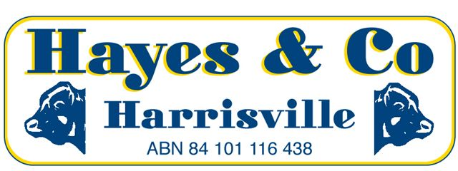
SILVERDALE CATTLE SALE MARKET REPORT

Wednesday 29th June 2016 579 Head
A quality yarding again sold to unprecedented rates for all types.
Description | C/kg | Vendor | kg | $
COWS | 314.2 | AP & RA JACKWITZ | 630 | 1979.00
COWS | 305.2 | G & R WEBSTER | 575 | 1755.00
MEDIUM COWS | 305.2 | D CUMMINS | 510 | 1557.00
DAIRY CULLS | 246.2 | GB & BE LAEGEL | 585 | 1440.00
MEATWORKS BULLS | 300.2 | B & T HESSION | 640 | 1921.00
PASTURE OX | 335.2 | EA & JK WINDOLF | 593 | 1986.00
PASTURE OX (6-8 Tooth) | 334.2 | TIM DWYER | 596 | 1991.00
FEEDER STEERS | 349.2 | TEIS & NOLAN | 456 | 1591.00
GRAIN ASSIST STEERS | 348.2 | COYNE & TOOTH | 421 | 1467.00
PASTURE STEERS | 349.2 | TEIS & NOLAN | 467 | 1631.00
PASTURE HEIFERS | 325.2 | L & A TABER | 468 | 1523.00
FEEDER HEIFERS | 327.2 | L ORTH | 410 | 1342.00
YEARLING STEERS | 317.2 | FINNEGAN FAMILY TRUST | 318 | 1007.00
YEARLING HEIFERS | 318.2 | B & T HESSION | 245 | 780.00
VEALER STEERS | 329.2 | GM SMITH | 208 | 685.00
VEALER HEIFERS | 316.2 | R & M DEWAR | 242 | 764.00
Office 07) 5463 8099 admin@hayesandco.com.au
Peter Hayes 0418 755 732 peter@hayesandco.com.au
Craig Bell 0417 434 095 craig@hayesandco.com.au
Landon Hayes 0448 052 187 landon@hayesandco.com.au

www.hayesandco.com.au

