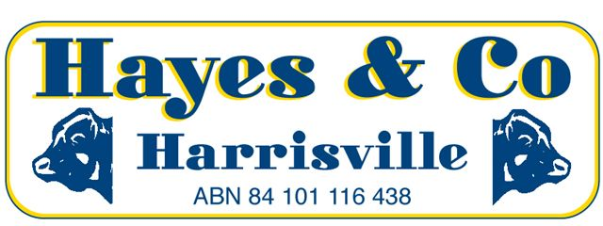
SILVERDALE CATTLE SALE MARKET REPORT

Wednesday 23rd March 2016 311 HEAD

A mixed quality yarding sold to a slightly easier market for most types while export cattle were fully firm for the quality offered.
Description | C/kg | Vendor | kg | $
COWS | 248.2 | KING & TURNBULL | 765 | 1899.00
COWS | 247.2 | DHJ & RE CHRISTENSEN | 575 | 1421.00
MEATWORKS BULLS | 250.2 | SUN VALLEY RURAL PTY LTD | 935 | 2339.00
PASTURE STEERS | 291.2 | PACIFIC VIEW FARMS | 475 | 1383.00
FEEDER STEERS | 291.2 | THE HOLLOW STATION | 450 | 1310.00
FEEDER STEERS [Light] | 294.2 | GW THOMSON | 335 | 986.00
FEEDER HEIFERS | 299.2 | M MURRAY | 400 | 1197.00
YEARLING HEIFERS | 308.2 | M KELLER | 325 | 1002.00
YEARLING STEERS | 308.2 | EST J SMITH | 265 | 817.00
VEALER STEERS | 308.2 | VS BURREN | 242 | 745.00
VEALER HEIFERS | 300.2 | S LUCK | 199 | 596.00
YEARLING BULLS [Replacement] | 401.2 | THE PA HAYES FAMILY TRUST | 335 | 1344.00

Office 07) 5463 8099 admin@hayesandco.com.au
Peter Hayes 0418 755 732 peter@hayesandco.com.au
Craig Bell 0417 434 095 craig@hayesandco.com.au
Landon Hayes 0448 052 187 landon@hayesandco.com.au

www.hayesandco.com.au

