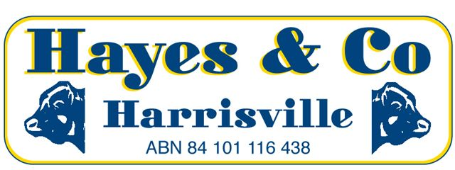
SILVERDALE CATTLE SALE MARKET REPORT

Wednesday 22nd June 2016 477 Head
A top quality yarding of local cattle sold to a very firm to dearer market for all descriptions this week as cattle prices continue to rise into unchartered territory.
Description | C/kg | Vendor | kg | $
COWS | 293.2 | D & R HOHENHAUS | 635 | 1862.00
COWS | 292.2 | BW WESTAWAY | 660 | 1929.00
DAIRY CULLS | 245.2 | P & N KLAN | 630 | 1545.00
MEATWORKS BULLS | 284.2 | MW HIGGS | 880 | 2501.00
PASTURE OX | 323.2 | TIM DWYER | 514 | 1661.00
PASTURE OX (Full Mouth) | 313.2 | STONELEIGH PASTORAL | 680 | 2130.00
FEEDER STEERS | 343.2 | T & JL BERDING | 478 | 1639.00
PASTURE STEERS | 342.2 | CUNNINGHAM PASTORAL | 470 | 1608.00
PASTURE HEIFERS | 316.2 | D & J HOOD FARMING | 355 | 1123.00
FEEDER HEIFERS | 315.2 | RUGBY FARMS | 344 | 1083.00
YEARLING STEERS | 320.2 | DN & FM MORRISON | 314 | 1004.00
YEARLING HEIFERS | 318.2 | DAFF TICK FEVER | 296 | 943.00
VEALER STEERS | 325.2 | JT RADKE | 285 | 927.00
VEALER HEIFERS | 305.2 | T & JL BERDING | 240 | 732.00
Office 07) 5463 8099 admin@hayesandco.com.au
Peter Hayes 0418 755 732 peter@hayesandco.com.au
Craig Bell 0417 434 095 craig@hayesandco.com.au
Landon Hayes 0448 052 187 landon@hayesandco.com.au

www.hayesandco.com.au

