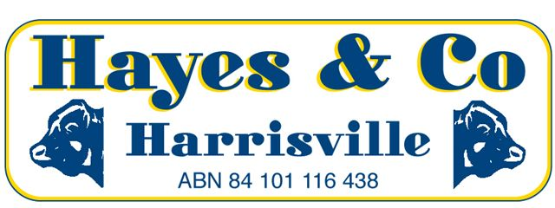
Market Report
Sarina Store Cattle Sale
Saturday 30th July 2016
Livestock Agent - Hayes & Co conducted the Sarina Store Cattle Sale Saturday 30th August. A larger yarding of very good quality cattle sold firm to slightly dearer.
Some of the highlights included:
In the Steer section: Wayne Pate of Colston Park sold droughtmaster steers 30mths for $1300. Allen and Karen Perry of Sarina sold brahman cross steers 24mths for $1100 also selling charbray steers 8mths for $770. Craig Ross of Bowen sold a line of grey brahman steers 15 -18mths with the top pen making $1100. Raoul Daniel of Sugarloaf sold droughtmaster steers 15mths for $1020. Scott Miotto of Sarina sold brahman steers 15mths for $1020. Neil Cunningham of Eungella sold droughtmaster cross steers 18mths for $1000. Leon Laird of Pindi Pindi sold brahman steers 10mths for $800. Andrew Jorgensen of Proserpine sold droughtmaster steers 10mths for $800. Robke Family of Donnybrook Grazing of Blue Mountain sold a line charbray/red brahman weaner steers with the top pen of charbray steers making $830 and the red brahman steers making $740. Thomas Anderson of Gargett sold droughtmater weaner steers for $700. George Fowler of Carmila sold brahman weaner steers for $680. Gavin Linthwaite of Mt. Funnel Pastoral Co sold charbray weaner steers up to $725. Jenny Morrison of Sarina Range sold droughtmaster weaner steers for $640. Jason Borg of Koumala sold charbray weaner steers for $680.
In the Heifer Section: Peter Ross of Ilbilbie sold brangus heifers 10mths for $840. Kris Thomas of Blue Mountain sold brahman heifers 12mths for $780. Allen and Karen Perry sold charbray heifers 10mths for $740. Dean Kane of Septimus sold grey brahman heifers 10mths for $710. Colin Baulch of Ilbilbie sold brahman cross weaner heifers to a top of $670.00. Peter Creber of Mackay sold simbrah weaner heifers for $660.00. Brian Harding of Proserpine sold droughtmaster weaner heifers for $720. Reg Maguire of Sarina sold a line of droughtmaster/brahman cross weaner heifers making up to $630. Thomas Anderson sold droughtmaster cross weaner heifers for $600.00. Vellaroo Grazing Co of Yalboroo sold brangus cross weaner heifers for $575 Barry Mathews of Yalbaroo sold droughtmaster weaner heifers for $590.
In the cow section: Neil Cunningham sold brahman cross cows up to $1320. Brian Harding sold a droughtmaster cow and calf for $1050.
Please note: The next Hayes & Co Sarina Store Cattle Sale is on Sat 20th of Aug at 10 am.
Peter Hayes  Eileen Falzon  Office | 0418 755 732  0448 067 554  07) 5463 8099 | peter@hayesandco.com.au  sarina@hayesandco.com.au  admin@hayesandco.com.au
www.hayesandco.com.au

