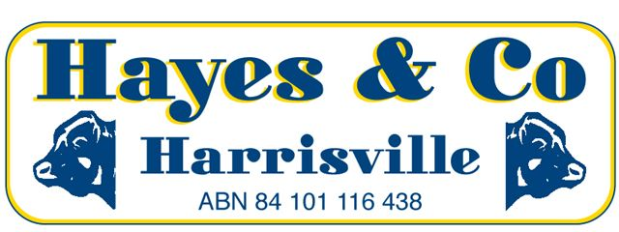
Market Report
Sarina Store Cattle Sale
Saturday 25th June 2016
Agent Hayes & Co: conducted the Sarina Store cattle sale on Saturday 25th June with a larger yarding of cattle. The market for the end of the Financial Year was firm to dearer for all descriptions.

Some of the highlights included:
In the Steer section Clarrie Hansen, Eton sold Brahman steers 30mths for $1390. Clarrie Lee, Colinville sold Brahman steers 2 years for $1020 with younger steers making $930. Viv Deguara, Grasstree Beach sold Brahman steers 15mths for $920. Doug Miller, Kuttabul sold Brangus steers 15mths for $990. Jason Borg, Koumala sold Brahman steers 6mths for $740 and Jason also sold Charbray steers 6mths for $695. Kevin Reeves, Sarina sold Charbray steers 8mths for $785 and he also sold Brangus steers 6mths for $710. Andrew and Mel Deguara of Melandy Harvesting, Pinevale sold Droughtmaster steers 8mths for $800. Peter Muscat, Habana sold Brangus steers 8mths for $800. Peter Doyle of Clarvilla Past Co sold a line of Brangus male calves with the top pen making $660. Margaret McFadzen, East Funnel Creek sold Brangus steers 5mths for $670.

In the Heifer section Viv Deguara sold Brahman heifers 15-18mths with the top pen making $950. Peter Muscat sold a Red Brangus heifer 15mths for $960. Mark Cahill sold Brangus heifers for $900 with a younger pen making $820. Clare Lee sold Brahman heifers 18mths for $900. Peter Doyle sold Red Brangus heifers 15mths for 750. Rob Bowman of Baumack P/L sold Brahman cross heifers 15mths for $800. Jason Borg sold Charbray weaner heifers for $640. Kevin Reeves sold Charbray weaner heifers for a top price of $580. Andrew and Mel Deguara sold Droughtmaster weaner heifers for $565. Peter Doyle of Clarvilla P/L sold a line of Brangus weaner heifers with the top pen making $500. Rod Knusten and Jane Linder, Koumala sold Belmont Red weaner heifers for $500.

In the cow section Clarrie Hansen sold Brahman cross cows for $1105. Rod Bowman sold Brahman cross cows for $960. Clarrie Lee sold Brahman cows for $1030.
Please Note: The next Hayes & Co Sarina Store Cattle Sale is on Saturday 16th of July at 10 am.
Peter Hayes  Eileen Falzon  Office | 0418 755 732  0448 067 554  07) 5463 8099 | peter@hayesandco.com.au  sarina@hayesandco.com.au  admin@hayesandco.com.au
www.hayesandco.com.au

